Data Collection and Preprocessing Phase

Date | 19 feb 2026
Team ID | LTVIP2026TMIDS66155
Project Title | Dog Breed Identification using Transfer Learning
Maximum Marks | 6 Marks

Preprocessing
The images will be preprocessed by resizing, normalizing, augmenting, denoising, adjusting contrast, detecting edges, converting color space, cropping, batch normalizing, and whitening data. These steps will enhance data quality, promote model generalization, and improve convergence during neural network training, ensuring robust and efficient performance across various computer vision tasks.

Section | Description
Data Overview | The dataset is from Kaggle. It contains 541 images with 8 classes. The eight classes of breed of dog are beagle, bulldog, dalmatian, german-sheperd, husky, labrador-retriever, poodle, rottweiler
Resizing | The image is resized into a target size of 224 x 224 x 3.
Normalization | Normalized pixel value between 0 to 1.
Data Augmentation | Applied Data augmentation techniques such as flipping, rotation, shifting, zooming, or shearing.
Denoising | -

Edge Detection | -
Color Space Conversion | The images are already in RGB. So, no color space conversion is done.
Image Cropping | -
Batch Normalization | -
Data Preprocessing Code Screenshots
Loading Data | 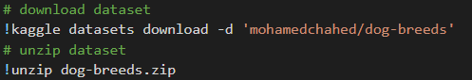
Resizing | 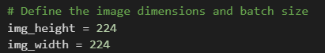
Normalization | 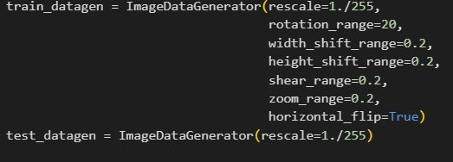
Data Augmentation | 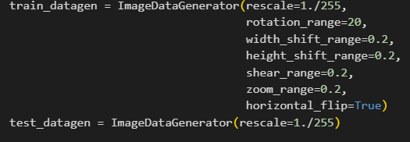
Denoising | -

Edge Detection | -
Color Space Conversion | -
Image Cropping | -
Batch Normalization | -

